1. Create user with name techie and provide sudo access to user.

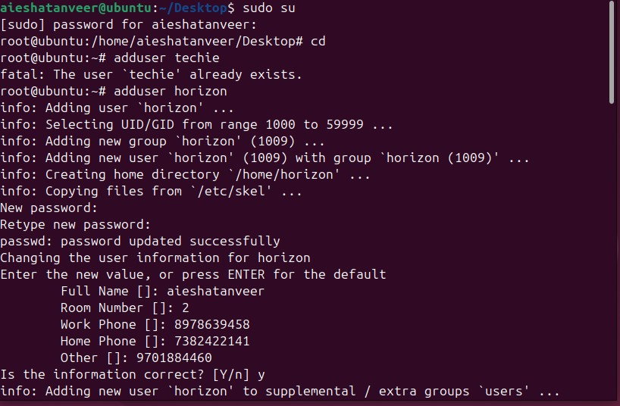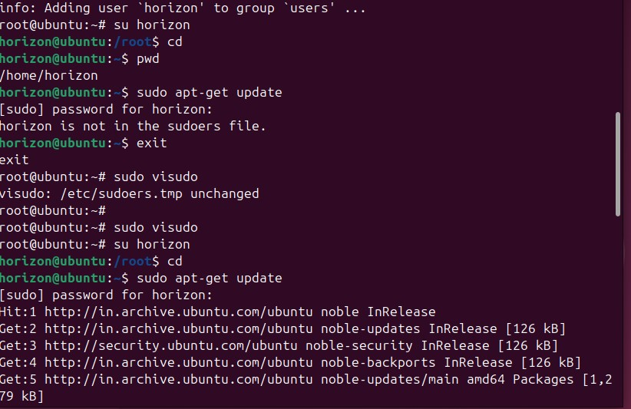

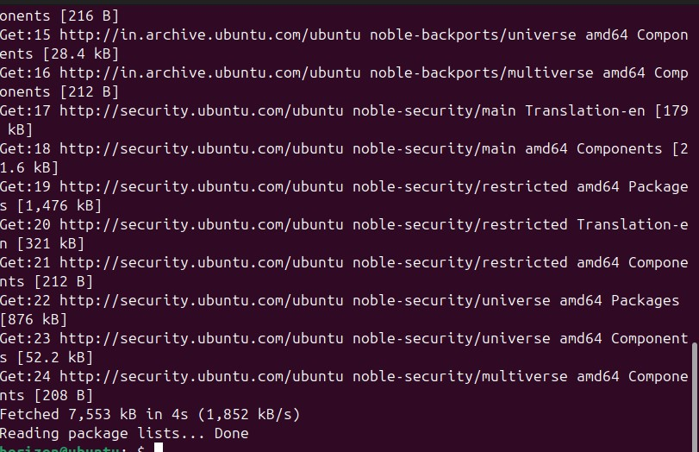

1. Navigate to the home directory.



1. Create a new directory.

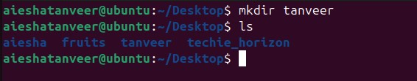

1. List the contents of a directory.

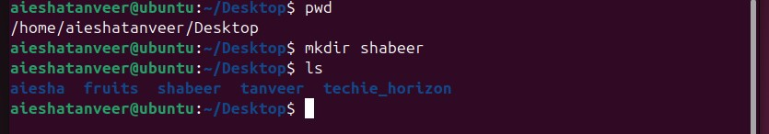

1. Change the current directory.

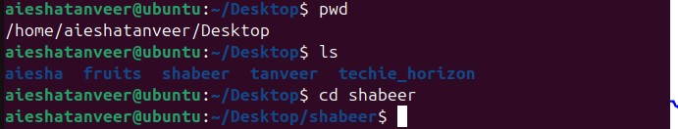

1. Create a new empty file.

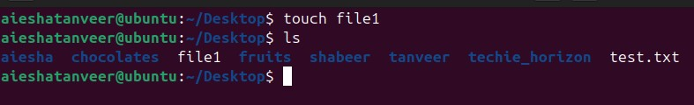

1. View the contents of the file.

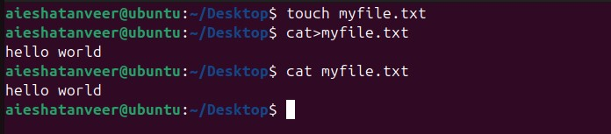

1. Copy a file to another location.

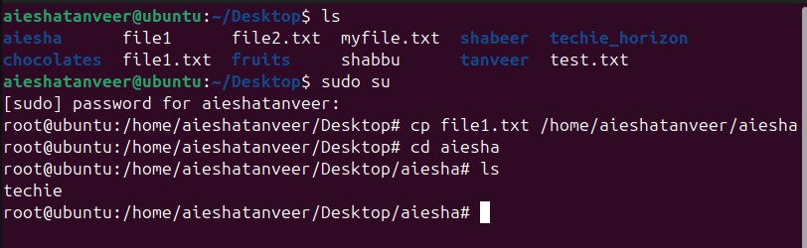

9.Move a file to another location.

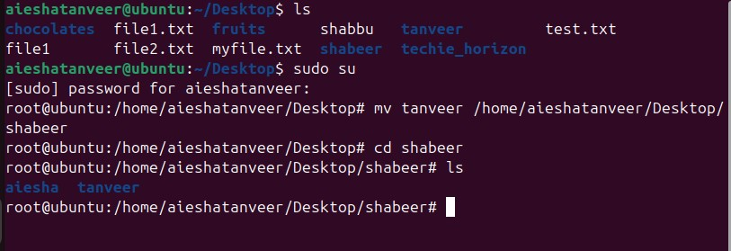

* 1. Rename a file.

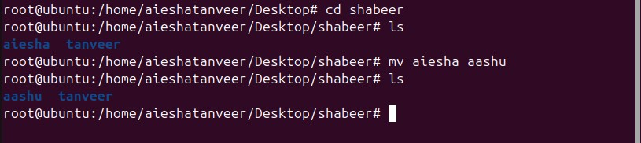

* 1. Delete a file.

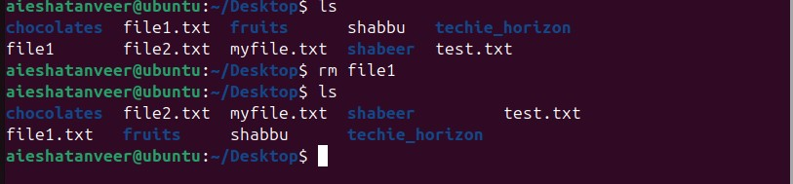

* 1. Grant or revoke permissions on a file or directory.

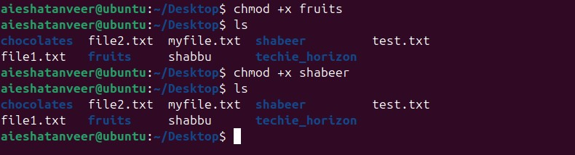

* 1. View the current date and time.



* 1. Check the system uptime.

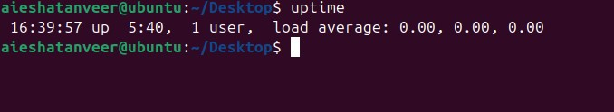

* 1. 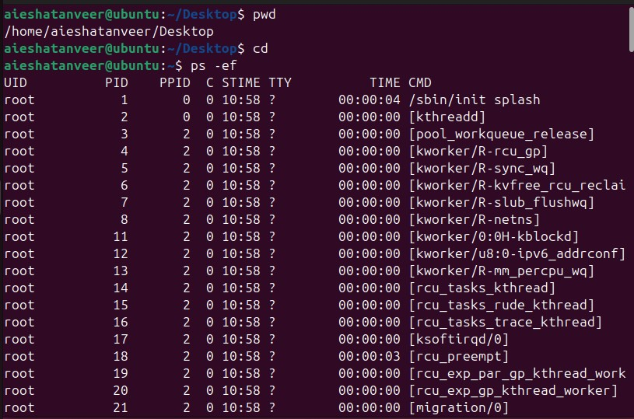View the running processes.
  2. Kill a running process.

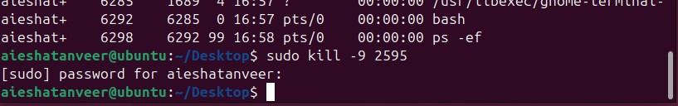

* 1. Install a package using the package manager (e.g.,apt or yum).

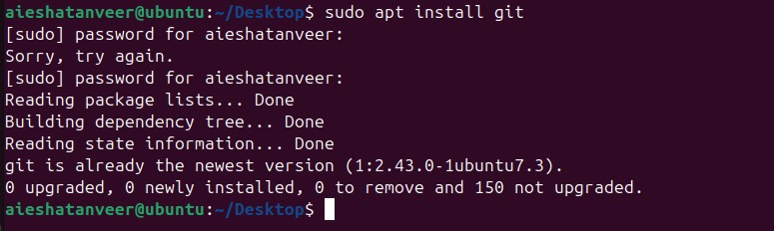

* 1. Update the system packages.

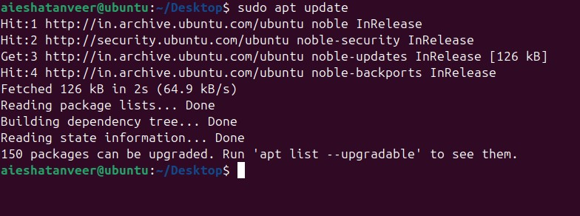

* 1. Create a symbolic link.

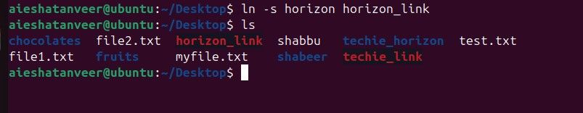

* 1. Search for files using the find command.

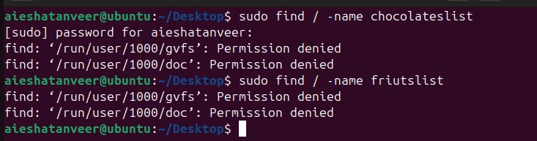

* 1. Compress and decompress files using tar.

Compress



Decompress

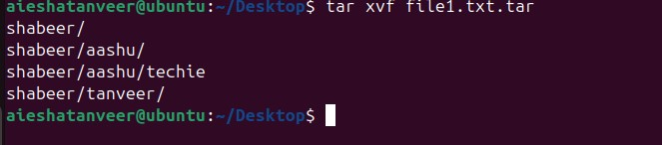

* 1. Monitor system resources with top or htop.

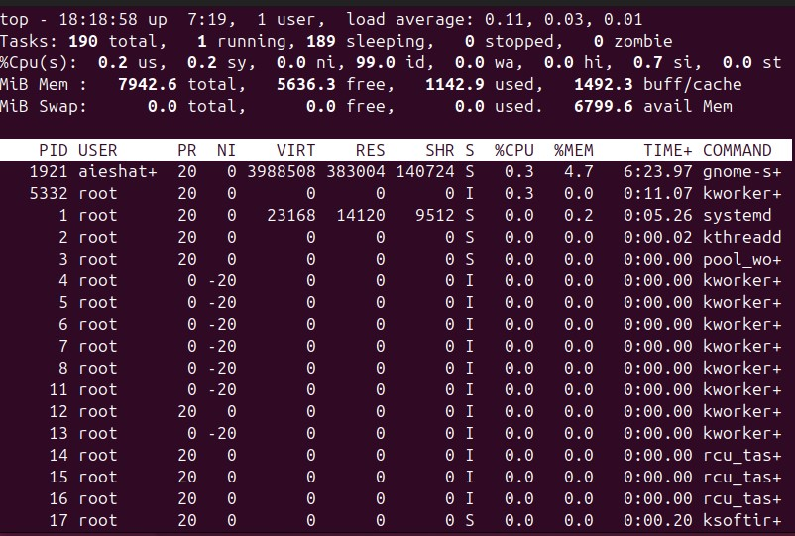

* 1. Create and manage user groups.

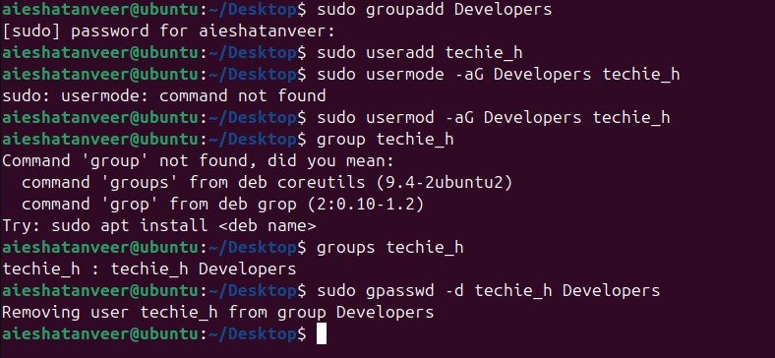

* 1. Set up SSH password less authentication.

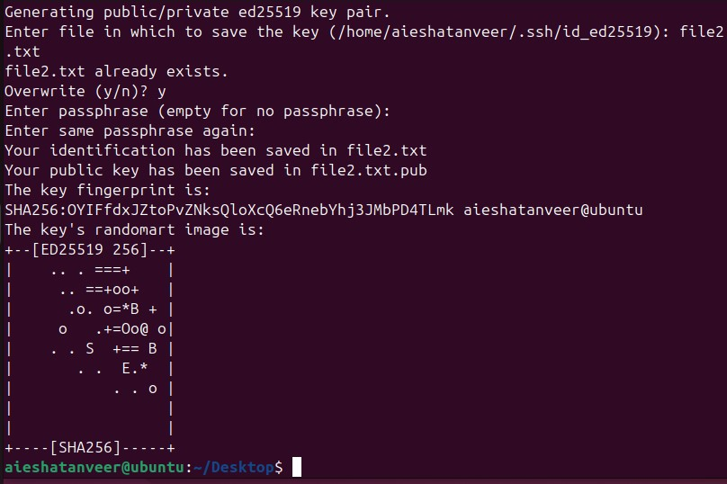

* 1. 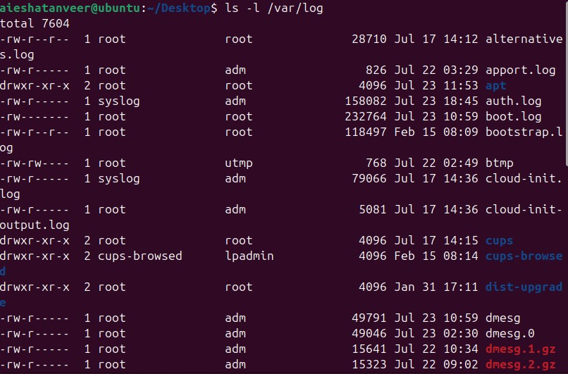Monitor log files using tail or grep.
  2. Set up a web server (e.g.,apache or Nginx).

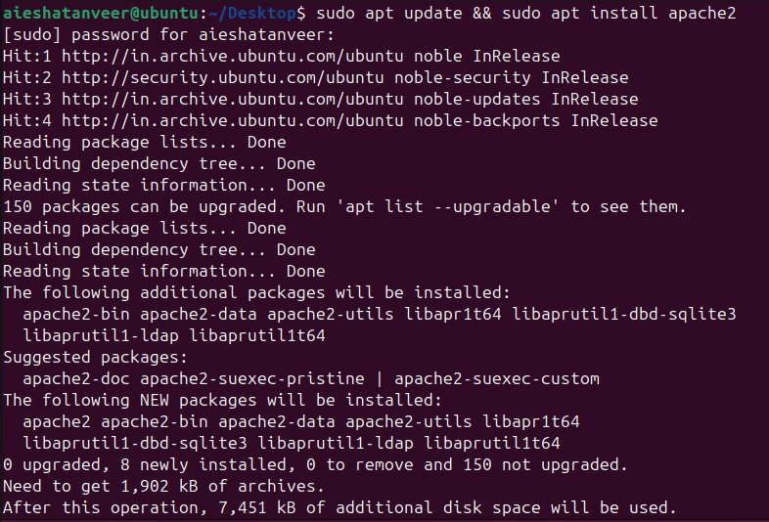

* 1. Configure and secure a MySQL Database.

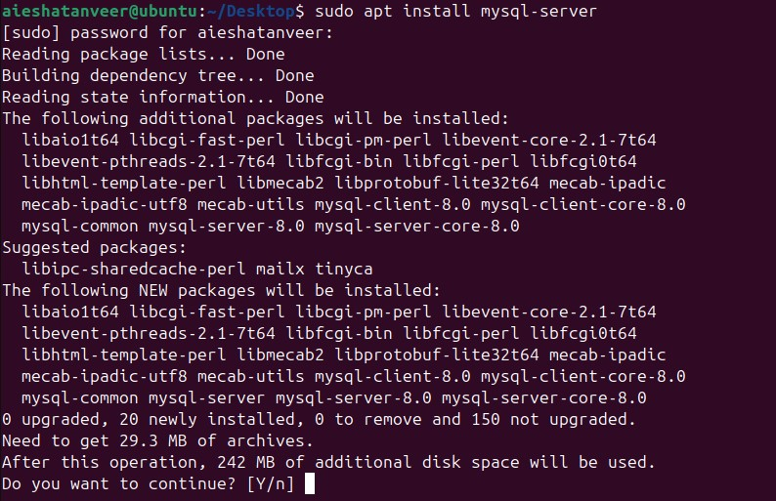

* 1. Set up a application server (e.g.,Apache Tomcat).

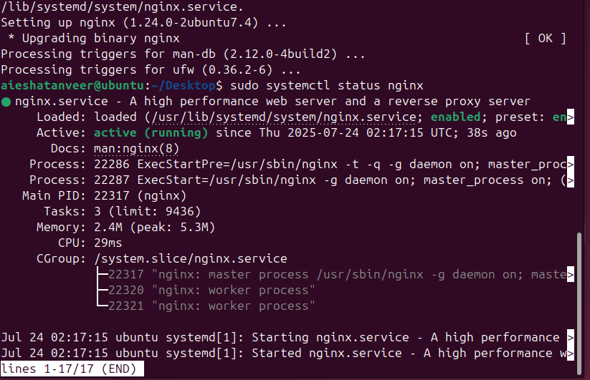

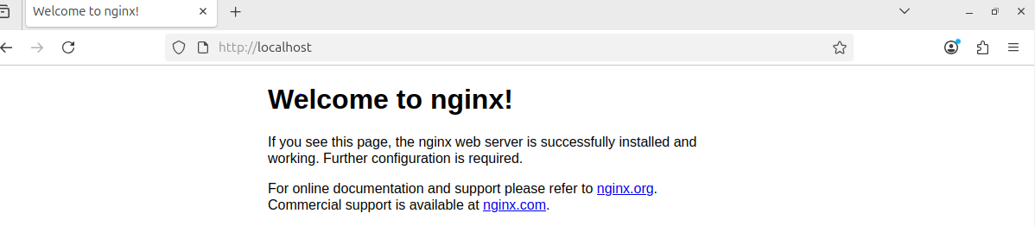

* 1. Create a service file for Apache tomcat.(should execute by using systemctl command)

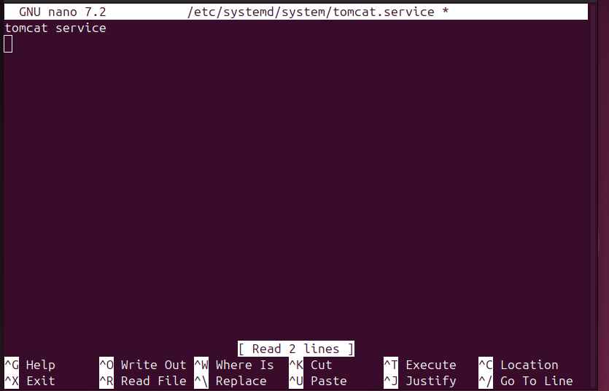

* 1. Print specific columns from a delimited file.

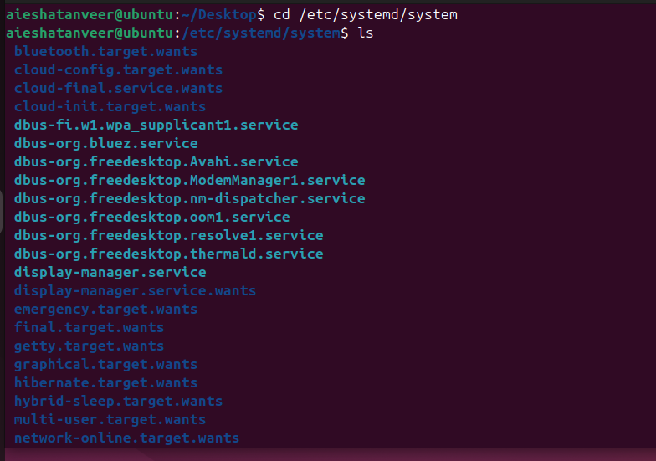

* 1. Filter and print lines based on a specific pattern or condition.

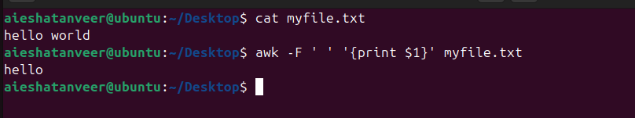

* 1. Calculate and print the average, sum, or the other statistics of a column.

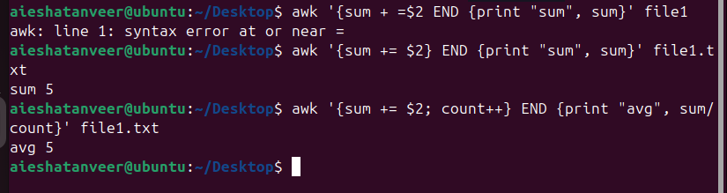

* 1. Perform string manipulation , such as extracting substrings or changing case.

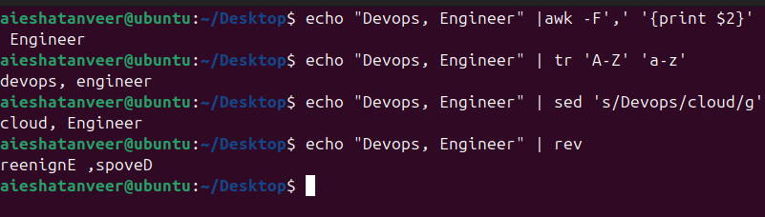

34.Count the occurrences of a specific pattern in a file.

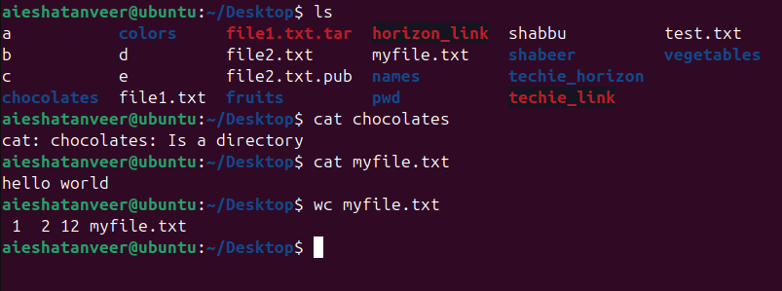

35.Sort lines based on a specific field or column.

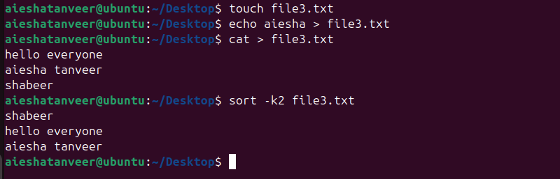

36. Merge multiple files based on a common field or column.

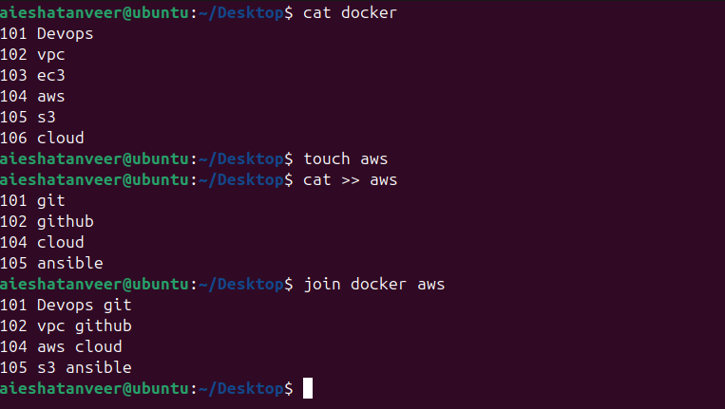

37. Substitute text in a file using search and relace.

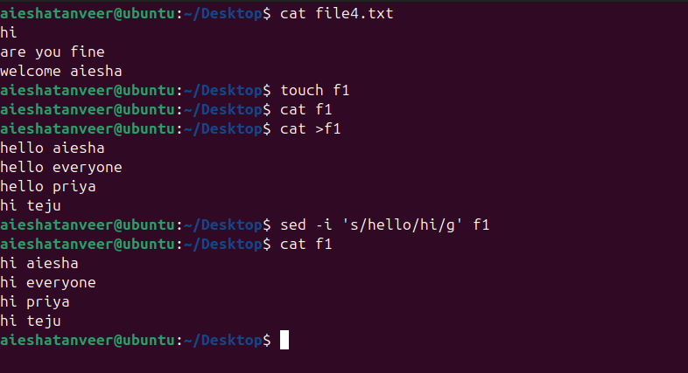

38. Delete specific lines based on a pattern or line number.

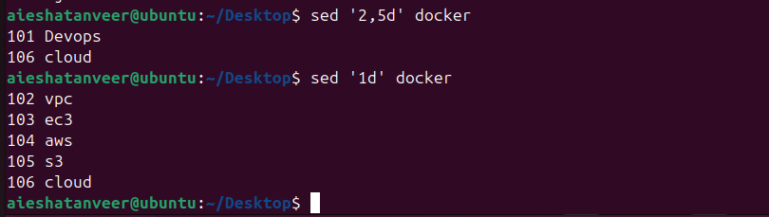

39. Append or insert text before or after a specific pattern or line.

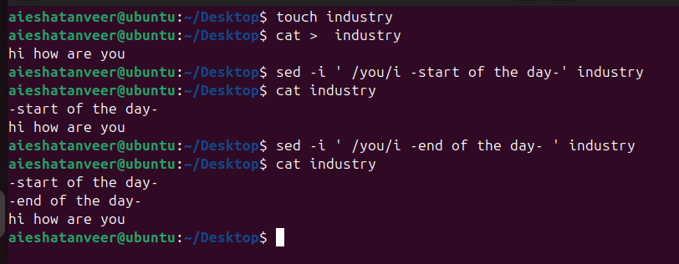

40. Print only specific lines from a file. 

42. 5 use cases for AWK and 5 use cases for sed.

5 use cases for sed



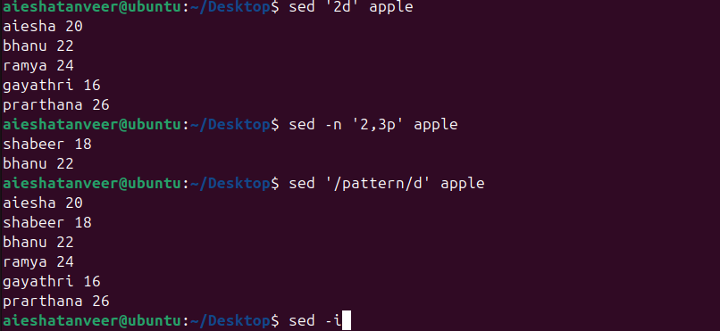

5 use cases for AWK

